**Grove - LED Strip Driver**

窗体顶端

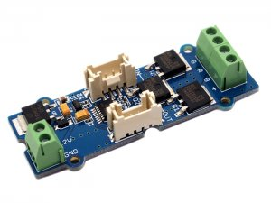

http://www.seeedstudio.com/depot/includes/templates/pure_green/images/next_l.gif

* [http://www.seeedstudio.com/depot/bmz_cache/b/bf01a93e0c29ef92a8c737b0d91d026b.image.55x41.jpg](http://www.seeedstudio.com/depot/images/product/LED%20Strip%20Driver.jpg)
* [http://www.seeedstudio.com/depot/bmz_cache/b/bacc9908f9ac1e907de6eb4095d29e77.image.55x41.jpg](http://www.seeedstudio.com/depot/images/product/LED%20Strip%20Driver_01.jpg)
* [http://www.seeedstudio.com/depot/bmz_cache/e/e48cdb4b4c2cb04d1b92996b5274c76a.image.55x41.jpg](http://www.seeedstudio.com/depot/images/product/LED%20Strip%20Driver_02.jpg)

http://www.seeedstudio.com/depot/includes/templates/pure_green/images/next_r.gif

* **Price:**

$9.50  [(Price Feedback)](javascript:void())

* **SKU:**

LED05241P

* **Weight:**

10Gram

* **Units in Stock**

57

* **Designed by:**

[Seeed Studio](http://www.seeedstudio.com/)



[Other products from designer](http://www.seeedstudio.com/depot/seeed-studio-m-23.html)

* **Quantity:** Max: 57  
  
* [Add to Wish List](http://www.seeedstudio.com/depot/index.php?main_page=un_wishlist&products_id=1197&cPath=163_169&action=un_add_wishlist)

Description

The LED Strip Driver with 4-pin Grove interface provides easy connectivity to your standard Arduino device or Seeed Stalker. It can help you control the luminance of a single-color LED strip, as well as the color and the luminance of an RGB LED strip through Arduino or Seeeduino.

It has 2 terminals and 2 Grove interfaces. The power for the LED strip comes in through the 2-pin terminal. And the LED controlling voltages output through the 4-pin terminal. The 2 Grove interfaces are respectively screen-printed “IN” (for controlling data input) and “OUT” (for controlling data shared with the next strip driver).

It can drive an LED strip 1 to 2 meters long with 9 V, while 1 to 5 meters long with 12 V.  The driver in conjunction with the colorful LED strips can add a wonderful effect to indoor or outdoor usages.

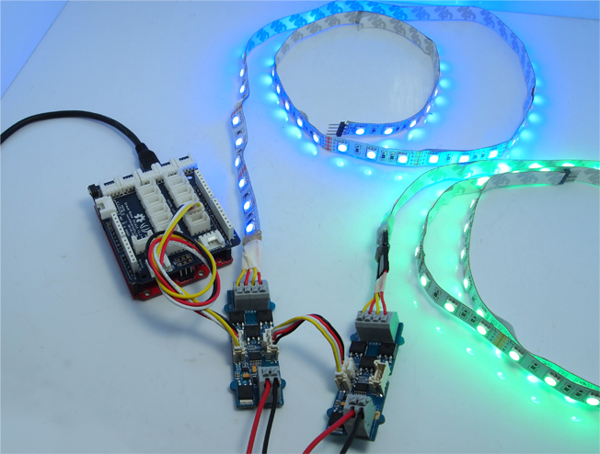

**Features**

* Grove compatible interface
* Can be cascaded for a larger display
* Best results achieved with LED strips 5 meters long or shorter
* Outputs PWM signals
* 256 gray-levels are adjustable via programming
* Arduino and MEGA compatible
* Screw Terminals (power input and control signal output interface)

**Documents**

Please visit our[wiki](http://www.seeedstudio.com/wiki/Grove_-_LED_Strip_Driver)page for more info about this product. It will be appreciated if  you can help us improve the documents, add more demo code or tutorials. For technical support, please post your questions to our [forum](http://www.seeedstudio.com/forum).

窗体底端